**DOCUMENTATION WORKSHOP-2 PROJECT OBJECT-ORIENTED PROGRAMMING: NOTION (NOTES APP)**

Juan Carlos Córdoba Asprilla – 20242020047

Sebastián Camilo Sánchez Cárdenas- 20242020086

Marzo 01 de 2025



Object-oriented Programming

**Ing. Carlos Andrés Sierra**

**CONCEPTUAL DESING UPDATES:**

1. Addition of the Note Class

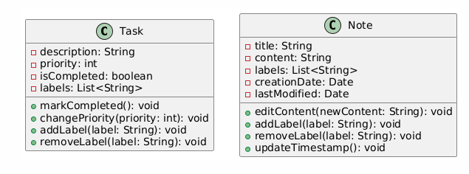

Reason:

Although the Notes class referenced a list of Note objects (notesList: List<Note>), the Note class itself was not explicitly defined. It has been created to represent a single note, fulfilling key user stories and functional requirements related to note creation, editing, tagging, and tracking modification times.

Attributes:

* title: String
* content: String
* labels: List<String>
* creationDate: Date
* lastModified: Date

Methods:

* editContent(newContent: String): void
* addLabel(label: String): void
* removeLabel(label: String): void
* updateTimestamp(): void

Relationships:

Notes --> Note

Note --> Storage

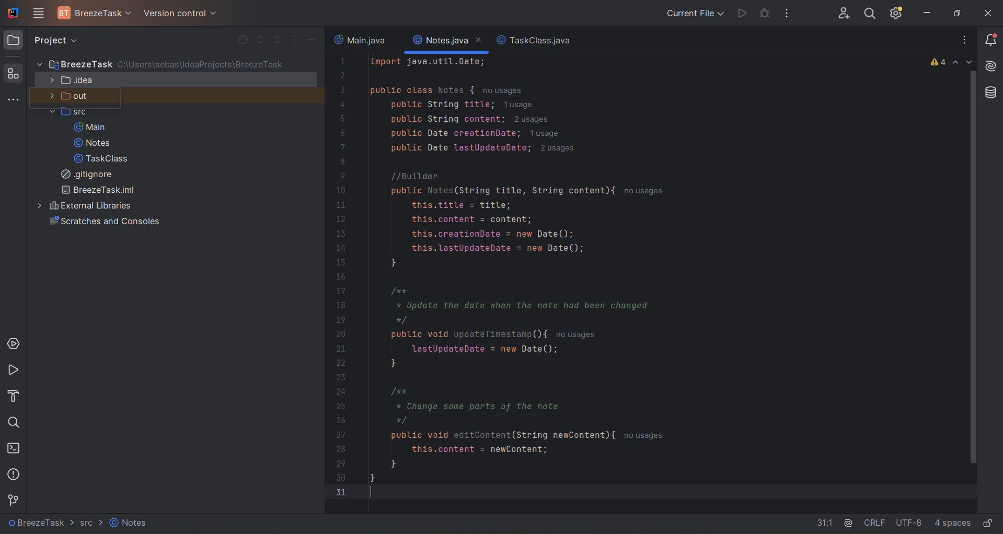

2. Addition of the Task Class



Reason:  
 The Tasks class was already listed as managing multiple tasks, but no definition existed for the individual Task entity. This class was added to model a single task with its priority, completion status, and labels—supporting user stories that involve goal tracking, task organization, and filtering.

Attributes:

* description: String
* priority: int (ejem., 1 = high, 2 = medium, 3 = low)
* isCompleted: boolean
* labels: List<String>

Methods:

* markCompleted(): void
* changePriority(priority: int): void
* addLabel(label: String): void
* removeLabel(label: String): void

Relationships:

Tasks --> Task

Task --> Storage

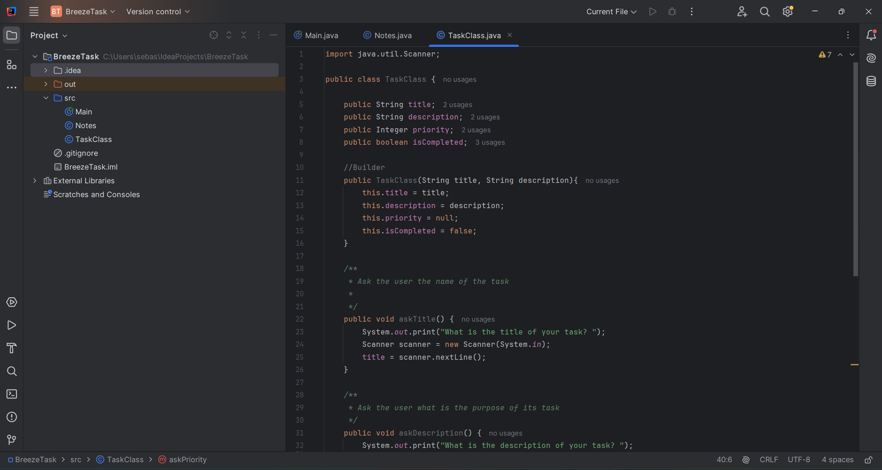

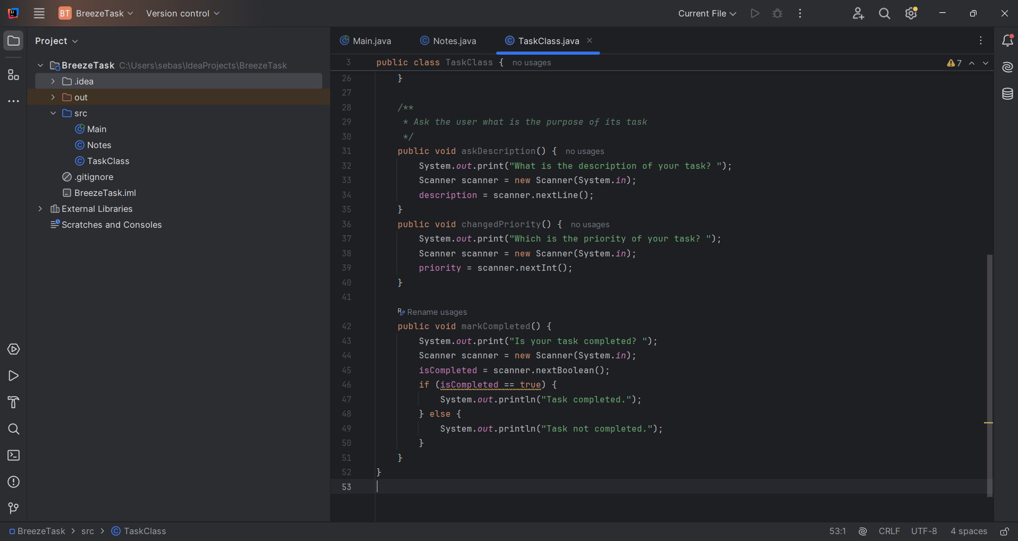

Application

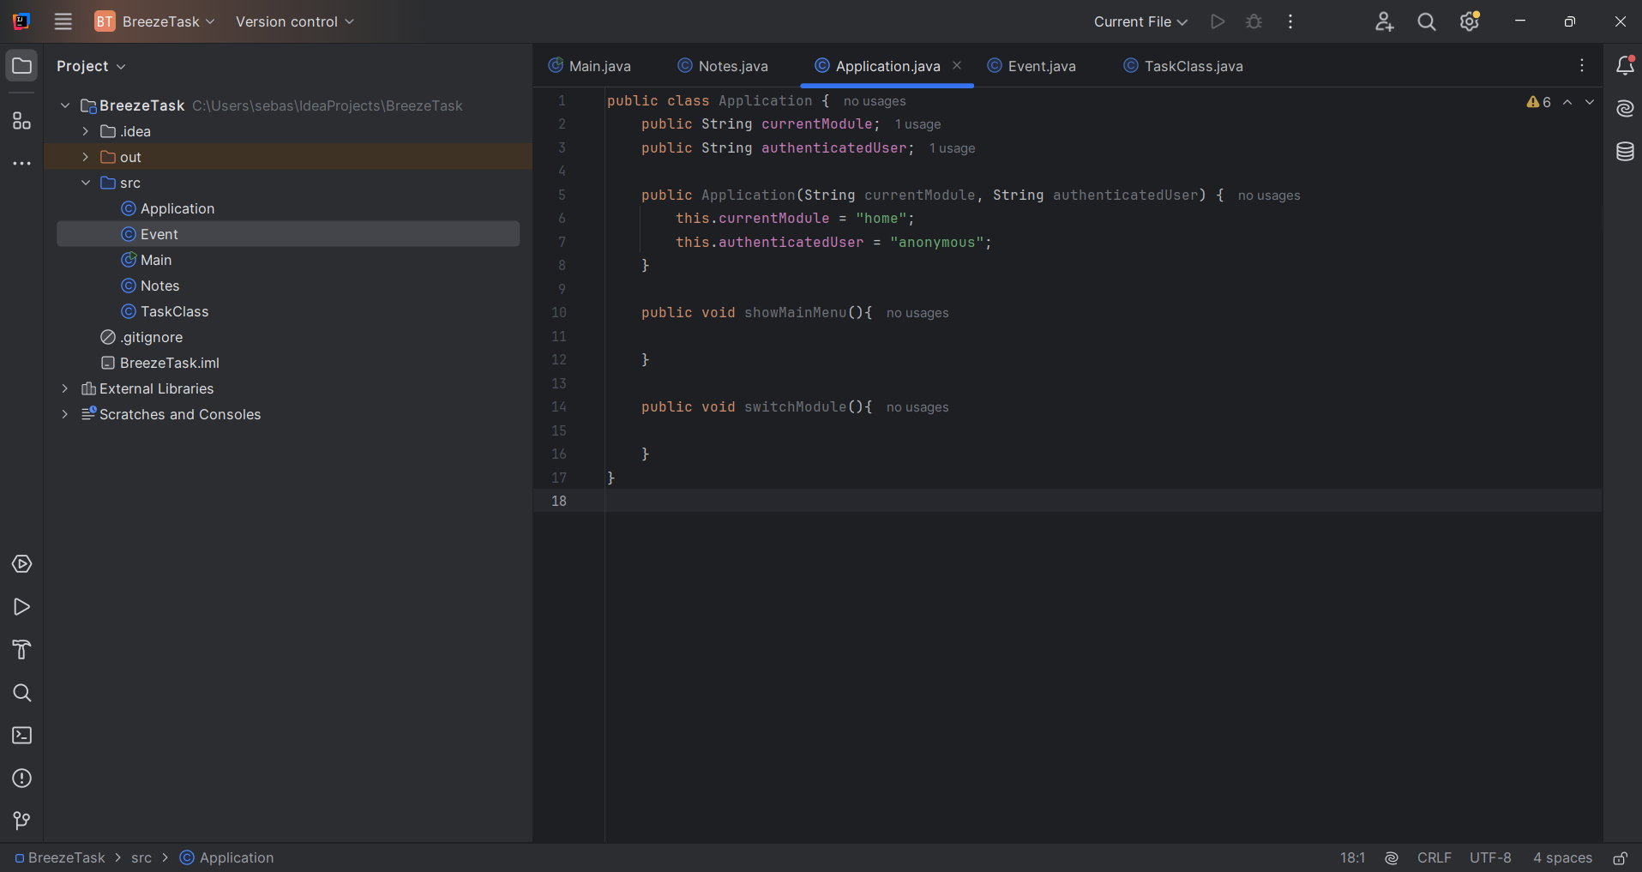

Event

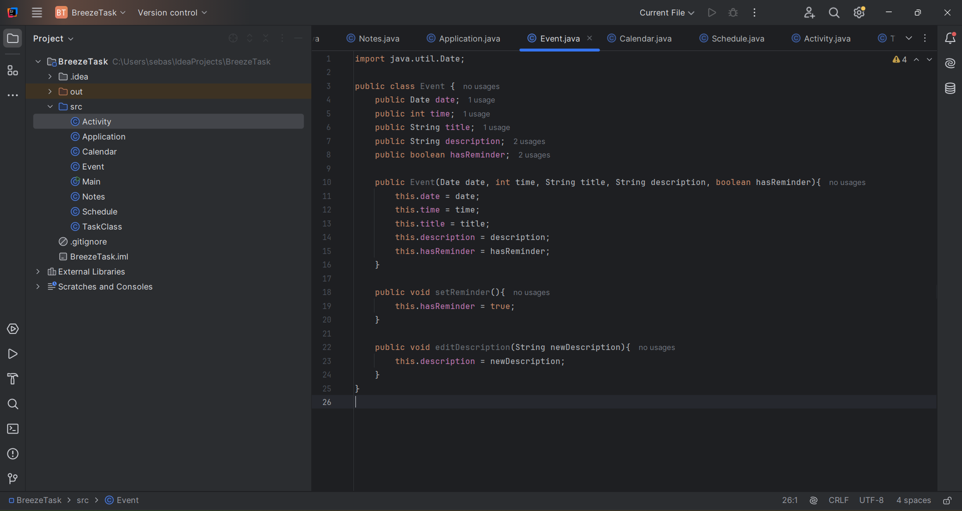

Calendar

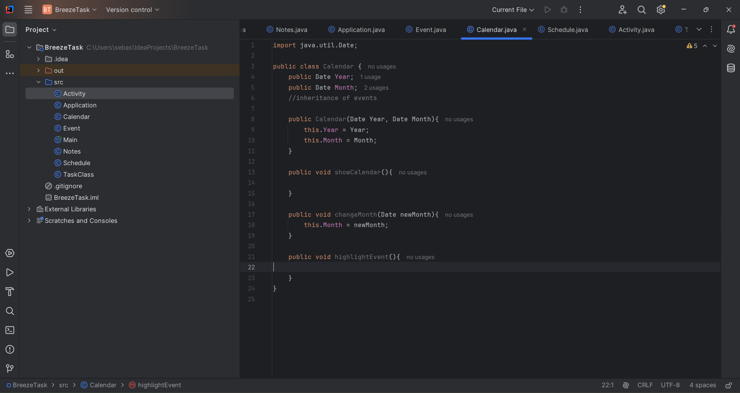

Schedule

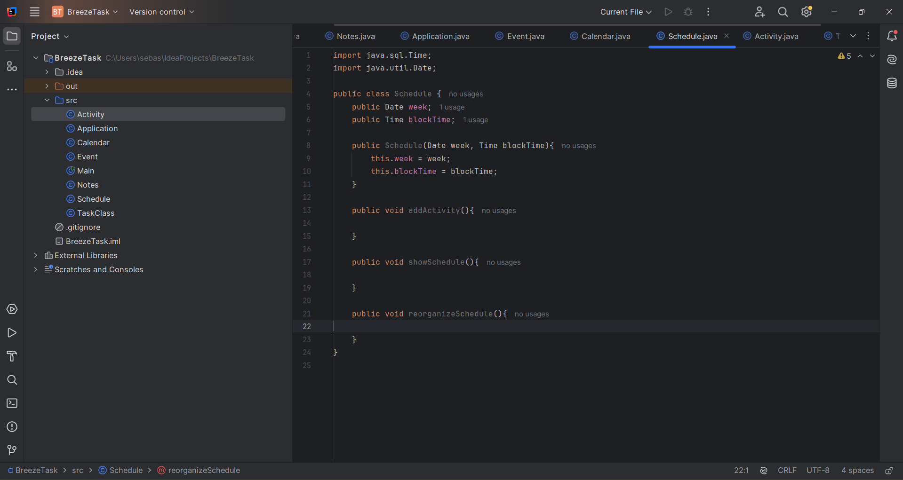

Activity

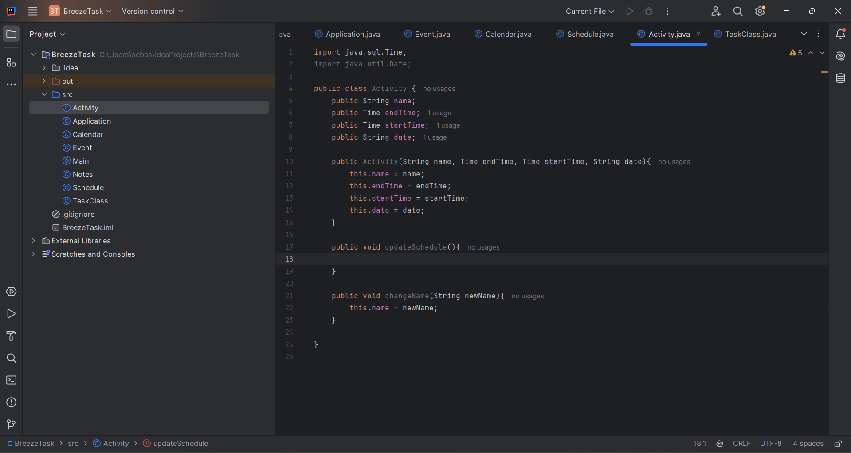

Task

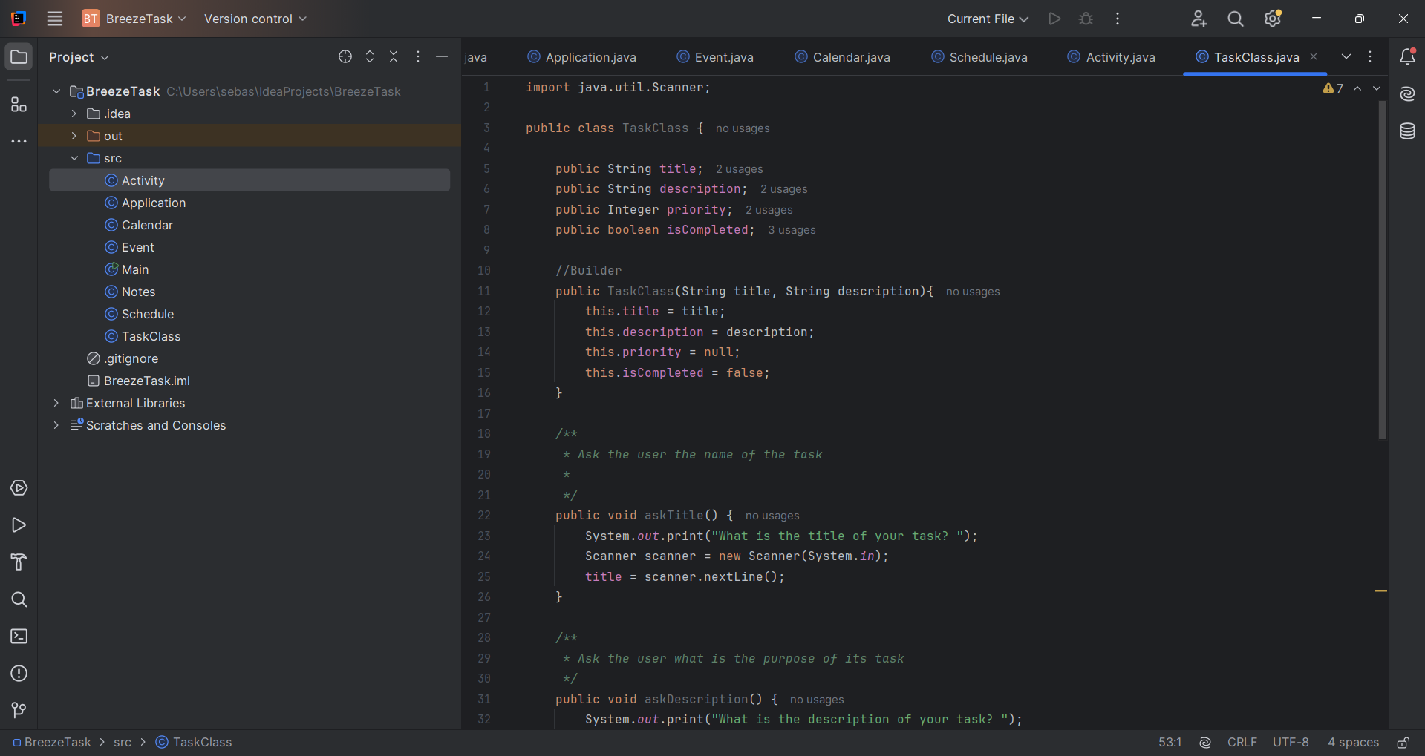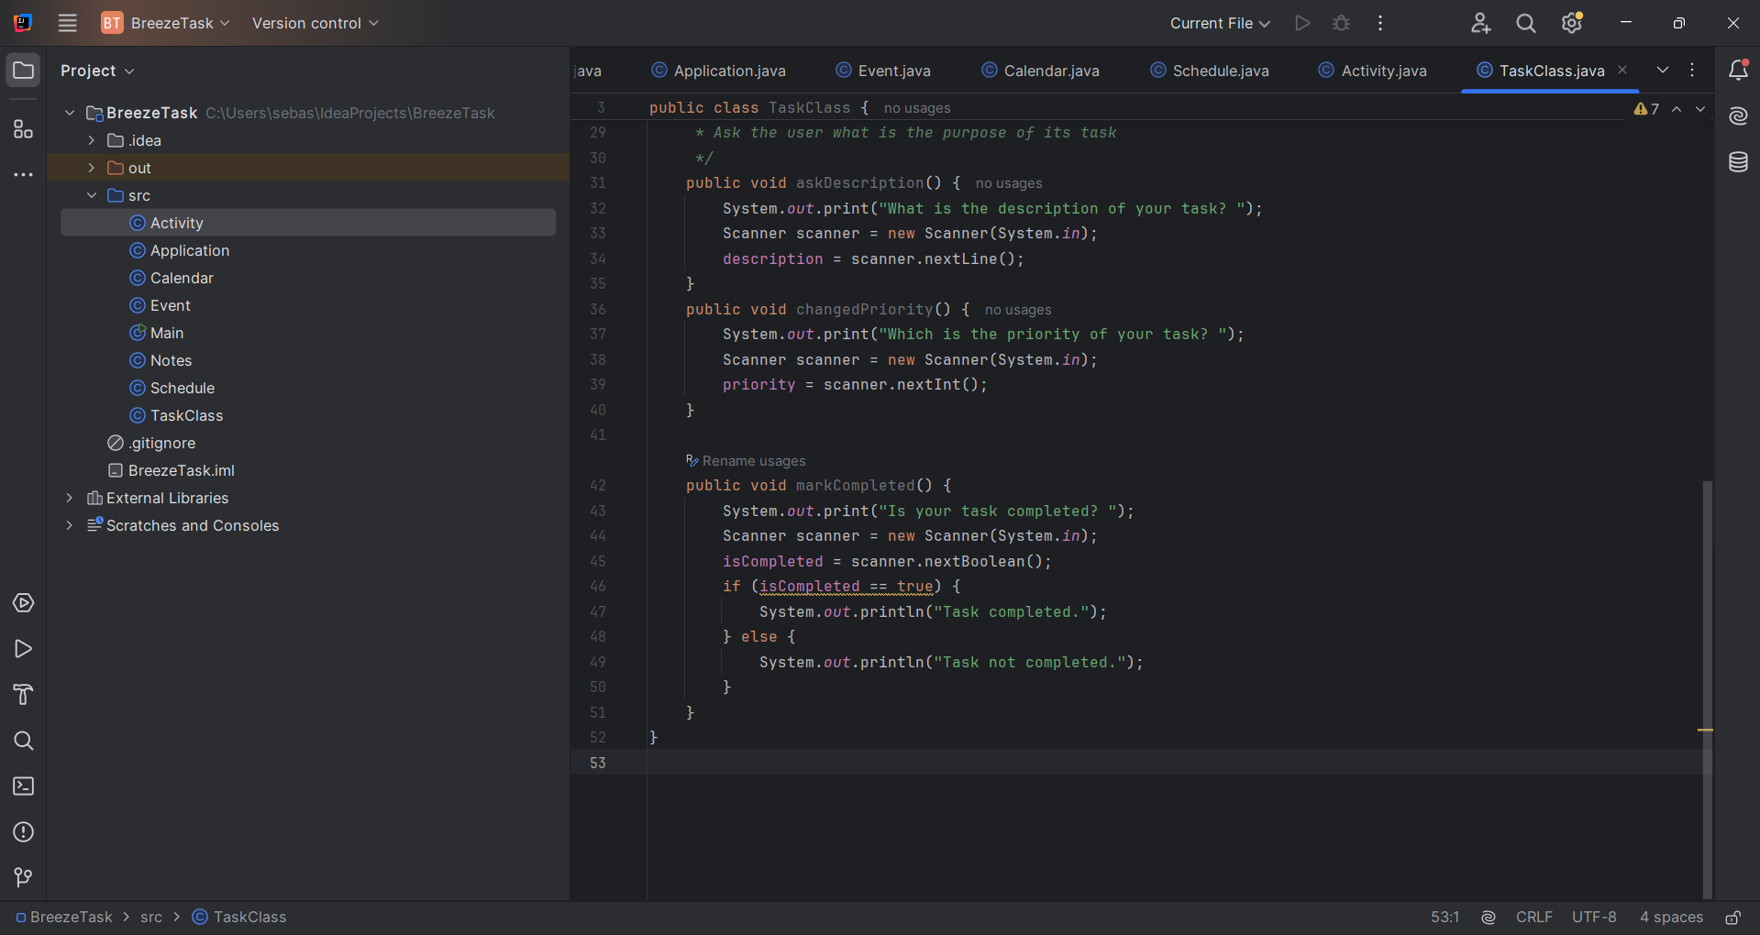

DIAGRAMS

[ACTIVITY DIAGRAM](https://www.plantuml.com/plantuml/png/bPL1Rziy38Rl_XL43n_QK-_9uMlgTDY0P2YQTdV2fcqXYkH9T8jitN-VHDUhOiz1Lw07yoLVqWyZ-SOpEkuEEdjzykHUCtdE5XliJD70gcsrAf2LDSjiiMli2snH6TYIwPPPrePS5KMu-6gPF6njsMcwW9yPXB_5ZZGL3A8j-z1Q-LRZiO-9Jo-e2YvNHVJw_mgu8GENkIDakX9PQkyCamDMhEcwiE71yF9TxTF5E8dky9c0BUpOEgpV5DAUOiExKd7YdpVM-eb3J89yqkwiyPeq9QEd95BhFcqSVMfBP1ePcr9LsQyJv8_eztF8HHiXbzXvvAkobBG9z3NvmgbM6gCfuTufwnGVax67seyosgBR1ww7DZ8e9wp6NfAE_hrYIcoZFFlJ9f-KPdBJ7Vzb_ZvLsehJFFWSTGYZcs4_oBr1VshopZao72eCDsVntps7l1CQ36jakdvK1xgEUvZ-vgNcezpp1arD_IH9dtjLxFjWOlH0bIFVm3T5BwSkdrNTwF2VZXflYoFq77tYyYUt7zJFatsWWp9bg9v1E-Xp1ENnERarvaf56P91yVZuuh_uXFGvfxYzbKPtk4hJAsL8bYextPBtMDDqhTDMqytEaTmL3KM2Co07-UnFKVWeFavkWq60BwQoeok0BSItkjMss8yEumDPLwDHFoYbuR26_s3jR0jfaOYn8W18nfrzNm7o_fvvGyKUAYk7L5Ll7p7n7Z06RMEnZ8l044_0tsAnxzg8nT7tZhpSDg7VOcDhsuKLUxPjTaEcZ5_Etm00) - [UML CLASS DIAGRAM](https://www.plantuml.com/plantuml/png/lLRDRjms4BxhATXJ5TH-WKLX971wAE2qHUgSXLbnl9ekVmHojAwxw5Fb4V9YbKOYTncfyQNeOONXnu_pp-6-ZGo11skgxxX3YogWrW5ZlDKGZdipO1MFv7e8O9KXX_pIe_A1ErzLtwlt18Tn1vH6rHg86DMd3m-gzROto7uKd2B7E99Q-lBPJRnVFEEDUeHuL2_AS_1HsI-VzM1yhAf9ILJl-jvG2qpZyNEbrArodZ7kv6mKWCVpSITgPg05Wqv3sAdxHH8ujXsEkd6dVbyaWGDQSXf7ziTPMjZi0nmcyYpCceSGqF47l-ZXGEuWEnG_3iwDgvtQUsyGN3NYFoXon0I6_iBwpKwTF6c1O-UV6mla6ejkABUUYTkkiMAZTc2peMjM1quR_1Gn_EpwWMkQlbj4uq7F_iR23Fv9d86_Kxebg-eiZ3OWC3PJlciclWHyCnMJqMtQGqqydo6zcof-enm-DzyueT4WOt7cUXkqRWpiqLmKod9BLK3hJ_WgVHNoqbf5b88KRY-Og8ixzK2HVvpnkvaSK1hrFV2ePVek_3Xr33qHwWpdNDtF5kenIVUREKf9U92WNWdz5TBGQs1y98kHmVRh-iibKkUSU1xNzVHfD31igRGGZiroor5l5R3jm1smwGFvGFnogKj2_gUI2_s936DezYyNVqetbhfEYRWhyx8qYSRO1kgdGXTjKQXPPi9zoakU2j_ge9pFVAnUv_6tRRV_srv9SUS1giwNiTKks8PpZVMEkrg-AxywEdHc_7639tGSrzttquIhysMENEMwbaDDhl2qjHNR0PF-vic7nQ5KLJ5m9pnecKx0sAJvNnfO-POUXvG9v0OC15lhVDjl59CTvKUoesmnHZXi3kzakox7O8PNnjE3TLs6k63rrpT7r4mTaeJYxgvqlrjOeZkDYAozdEAN-3Pgxy2MT47-pMvwLrD8S4BnivwT_NN_1xRyzKCsCzwaxUjdQW_jSIWcslLVXzlRk_bjMw4oyLPewllLHgh4QYFrnseZ_N-en7xsvBBC374bEoNBaf2y4b1wkP9lGHAaT2a91Iz58c1gWYe9fUjlqUdfds7r3m00) - [SECUENCE DIAGRAM](https://www.plantuml.com/plantuml/png/pLXDR-Cs4BthLmXxgHV8_e4UYbsalHL5qTsUYOauiOdeGw3e1FdtrMZyR36aBDWgq1vYI9mtmpSpvEWXNuT0FXoRklYf_DNHtbD3fULouEh8RUMexCbJMLDPrJHm-QtlQrTHS5rRK1KwN_uzi2z6K72LwwaDSqYq_aSNU8XM7gdcrbBi_hqwi3tM72t-nOrhBVkYaEtABx_CTob_BeT3zsOQSgrfk3tkFXSpiw35QuHPD_GrlPS2Mehqva9rC4qd77QV9jAVadZJyeYkF5DWquwluwQwceGKgr6aNQHMTUspyuqkDpmCjEVYAxTMUbCKD_P92IvqI8t9Ijo5qL4Oe4hPZ8CBDJy8zS1jGFudi2JERrdC37BiBGN-uSQC0pNzh8YW83sXLpOZZdQoxUS2bY_WzQ5-Y87gnYr8SsBhWcRax8EmDeif2VHHZRi8k2qlXLkpAJy9aitFSis1aU4A5O2tC94OMIPahQdfYUkfqjDJKcC1_JvXOFylIwiapSWfbu_dfdlbjPI0-zzbfRJiXZc34HwFcfKH_zihj-7wk84VPdjrUX_h0bDchWEL2rCTgDspQRes77RJRpRKgR1NGntS_b2FVy6mP3B4f3Iz4RPd0CnpvtNd4QhcgAzrHrRx6lSIaKvH107tY140jHl2Z8fcXHfUQBCzEMnelFOmttKrPZ_WLxkkVXZ8beVAkrxExux5OEI2oIfgk78t9gTSGUFBWM2NQirsJeSgGb0LtEjeClwKsfdaZ1xIdk775cFrGm8S3DNac-WGn374R4RWBCIC4fYOQIzE4mD0zjhGUqYqkFqh4kwRS7BX_Ve9W2lk_Q3lKZMOSlV-wBsa-iRyaeRIpmwTzj_XOJeiSLXmFEkSZs00beuUu747uVNXuCsYnNGH1OfbnZ4TLAZGXdw2HzJFcri7r9dRfNcGLS4rl5v4tD_xYuaQWG1kSOuiFWmjDHUYBTr2LD3tanHl4DpGn1yql2mfVZKcAzVxAGXejZ0-x-JdT0yc6q1G-gavMpN1nTLIU5mgnBZKIVnKXwKS6_8lfkgQVjATOnjJYW9vF2Do775imV8IyMwwicc6ByvSxrtdPIR9kSDBIbtHVm8Cu6eE01eDOEz90p7IAwJGlAQFKqWr_HhpcUY-X_JCFU4BpRv26RZRMQlV_RmH86N-xEh0tZozctxzB4IoKZtpbEIWgdJK68bkL6UsYjmmeY1QuYbrgqW4Af9CqeI7Khul3_ZlIQApaaa4ERIcjqYwWMMK9zPZO7UJuiDdCb0u3geTU8bBT79ICedwmrrDM5c-aPTh_pLcs7lRbqvfG7r-Vny2D_aZexQbzilFEIa1ANp4Y4NRZXXB5-kAl-Tmz6q-1FIbUQBgvTWlX56Z4UYyOly0)

Note: The diagrams shown below use classes with conceptual (yet to be defined) attributes and methods to establish their respective connections. In the future, the structure of these methods and the necessary attributes to include or exclude will be reviewed to ensure the application functions are as intended.

**APPLICATION OF OOP CONCEPTS**

At this stage of the application's development, the use of object-oriented programming principles is not yet fully defined or implemented, as many functionalities are focused on direct user interaction with specific modules.

Regarding **encapsulation**, protecting the user's information has been considered essential, especially since this is a local application — without online connectivity — meaning all data will be stored directly on the user's device. Therefore, appropriate access modifiers are planned to restrict direct access to attributes and ensure that any modifications are handled through well-defined public methods.

Concerning **inheritance**, the possibility of creating a base class called Module has been considered, from which components such as calendar, notes, tasks, and reminders could be derived. However, this decision is still under evaluation, as it must be determined whether it truly adds value or introduces unnecessary complexity into the design.

Lastly, regarding **polymorphism**, its implementation is not currently anticipated, as each class’s responsibilities are clearly defined and do not require flexible or alternative behaviors. Each module operates independently and fulfills specific tasks, making the use of this concept currently unnecessary.

[PACKAGE ESTRUCTURE](https://www.plantuml.com/plantuml/png/lLRDRkCs4BxhAOYzL8icBs0KmIwyFHJ8jiN-d8MnE97PYAHAZfnwZJnL7w4lLeeYQT9XwbFtO7dqpGpdXn-7UcS93CroR7vW7mGC1YGmZgmVmQ9bHpR1dpEI4xz-l7Sl1fZ1oQ15vHpP24oR0PJu1htuvs_5fERpw1GSHsQ59PJGD1FqZp0WU_D-caRH0mcjs5ORVCDE3VEnBCjq7cNibYbDQ3Vir-KlG0JsqK5Vt5-4UXXHSJ0RjWrIKDX-ZouTtB3FGGeAWr8eZixZKv2Y1sa3m-Am2Z72R0mg-gZ3QcI46e9Es4-pKkvzmtPQZmYgyPeVcL2218pY6xPlD-oW1GyAkzTFdGIXEebglbG-2UhtdVInMWKo1Ipjzg3uY5yjcb_KD5ChbcVTTDJ0rzpjHJ3yIr06FJVFsMxvjZFlMEpKYf_24hr18EoK0riITExF3Ukr8bIl98LSqEeb-8O9HJTCuLFtdpuSHoGil4e3uBmROOVZUL7_Mb_EeDG7lEeGUrCq876qg3bWPH4HzGixxjuBIp-jchleOD0p_mEGMsjv9X-xq4uy2EIP8klXTetLkkPjwxrBhRdtXLvjo5MpUU90-4L8j0HoUfL0_f1M2BJYfspFo27jykWu4DIZIZ2FZXvoMZZ0w_lVxq4Ds4r6Q2FeUDxKY7m_paI71p4IccvtF6TL9XC8iJJbhkJP0YMUSRIz4TF2af9NPMrfAcrZfz9SkaR3hC_9kQtrz_Tg8VyBtKf2nVbUuLHIdV8XsmUqMaOdjQ9zwv-L2lPYs8_kHnqUK95jgxFWvqN7JlbGotQgzQvTuicYglTYm1YdUz0cf1QvuOFSnSxs90v0sCLRh0poMk_YJLSxa46NDG-fWn6CR7cQI3UCX7IoE_TEbcWj35Wl9gRONexlJ57FCbxKbIIZgjnX6z3svQ7smHQQHg4SBhNTV1yisQaOTIbAULUT-r6bbm9PEdZa6iV3bmVxVBI4Ccz0rAJwuO2-f7QjwxVT7zZJowj_jNaR3SfxU-VYpYz6UFunTdjxjrxvb-Wwno_HT18l5Ma3BnM9VfUAM77J-FWfa_YQMVXKKbBnDJE8MNdGdwV6FtEZYEGfHQ6mYvLuC7AcYK9X-WuLNpwl_mK0)

WORK IN PROGRESS

Application



Event



Calendar



Schedule



Activity



Task



